Installation Guide

1. Store the backup file (demo.bak) in SQL Server 2014 or higher make sure the database contains all the required tables as mentioned in the below screenshot:

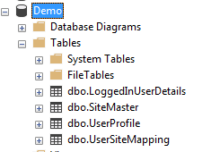

1. Change the connection string in both the site to the database server machine.
2. Host both the application Site1 and Site2 on localhost.
3. If you register form any of the site please do a manual mapping of that site to the username because we don’t have any module which do this assignment.

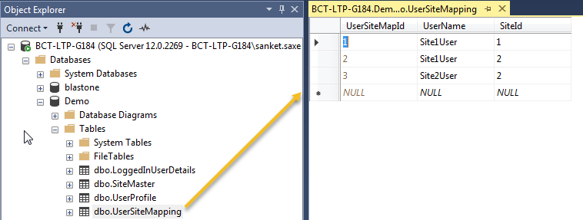

1. Ensure all the type table are in the correct place as per below screenshot:

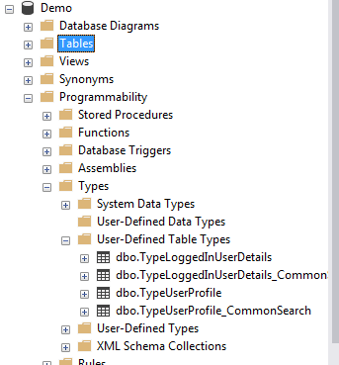

1. Currently available user in the databases:

Username: Site1user

Password:test

Username: Site2user

Password:test